**Math 7553 – Spring 2018**

**HW #3 (Hand In)**

**Shuddha Chowdhury**

**Submission Date: 04/03/2018**

Chapter 8: Exercise 8

In the lab, a classification tree was applied to the Carseats data set after converting Sales into a qualitative response variable. Now we will seek to predict Sales using regression trees and related approaches, treating the response as a quantitative variable.

Split the data set into a training set and a test set.

Ans:

library(ISLR)  
attach(Carseats)  
set.seed(1)

#splitting the data into training and test data set

train = sample(dim(Carseats)[1], dim(Carseats)[1]/2)  
Carseats.train = Carseats[train, ]  
Carseats.test = Carseats[-train, ]

(b) Fit a regression tree to the training set. Plot the tree, and interpret the results. What test error rate do you obtain?

Ans :

**library**(tree)  
tree.carseats = **tree**(Sales ~ ., data = Carseats.train)  
**summary**(tree.carseats)

##   
## Regression tree:  
## tree(formula = Sales ~ ., data = Carseats.train)  
## Variables actually used in tree construction:  
## [1] "ShelveLoc" "Price" "Age" "Advertising" "Income"   
## [6] "CompPrice"   
## Number of terminal nodes: 18   
## Residual mean deviance: 2.36 = 429.5 / 182   
## Distribution of residuals:  
## Min. 1st Qu. Median Mean 3rd Qu. Max.   
## -4.2570 -1.0360 0.1024 0.0000 0.9301 3.9130

**plot**(tree.carseats)  
**text**(tree.carseats, pretty = 0)

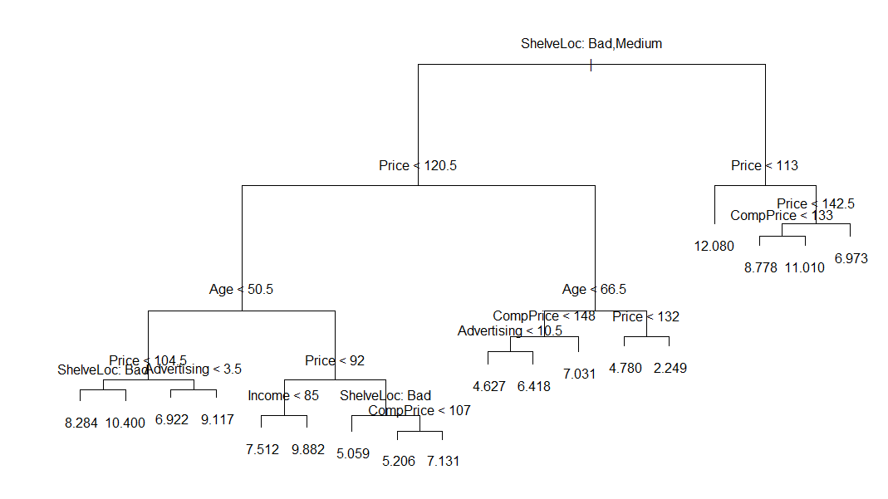

pred.carseats = predict(tree.carseats, Carseats.test)  
mean((Carseats.test$Sales - pred.carseats)^2)

## [1] 4.148897

# Reference - https://cran.r-project.org/web/packages/tree/tree.pdf

https://www.rdocumentation.org/packages/tree/versions/1.0-37

(c) Use cross-validation in order to determine the optimal level of

tree complexity. Does pruning the tree improve the test error

rate?

Ans:

cv.carseats = cv.tree(tree.carseats, FUN = prune.tree)  
par(mfrow = c(1, 2))  
plot(cv.carseats$size, cv.carseats$dev, type = "b")  
plot(cv.carseats$k, cv.carseats$dev, type = "b")

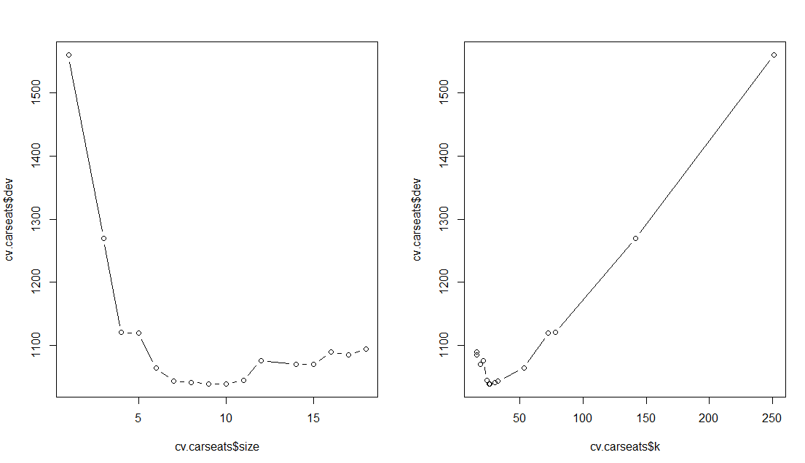

pruned.carseats = prune.tree(tree.carseats, best = 9)  
par(mfrow = c(1, 1))  
plot(pruned.carseats)  
text(pruned.carseats, pretty = 0)

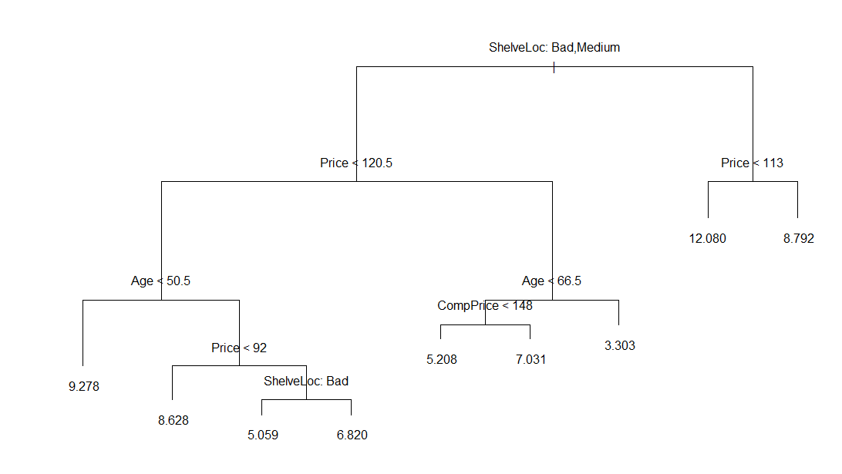

pred.pruned = predict(pruned.carseats, Carseats.test)  
mean((Carseats.test$Sales - pred.pruned)^2)

## [1] 4.993124

When we prune the tree, we noticed that the test MSE increases to 4.99.

(d) Use the bagging approach in order to analyze this data. What

test error rate do you obtain? Use the importance() function to

determine which variables are most important.

Ans :

library(randomForest)

## Warning: package 'randomForest' was built under R version 3.4.4

## randomForest 4.6-14

## Type rfNews() to see new features/changes/bug fixes.

bag.carseats = randomForest(Sales ~ ., data = Carseats.train, mtry = 10, ntree = 500, importance = T)  
bag.pred = predict(bag.carseats, Carseats.test)  
mean((Carseats.test$Sales - bag.pred)^2)

## [1] 2.633915

importance(bag.carseats)

## %IncMSE IncNodePurity  
## CompPrice 16.9874366 126.852848  
## Income 3.8985402 78.314126  
## Advertising 16.5698586 123.702901  
## Population 0.6487058 62.328851  
## Price 55.3976775 514.654890  
## ShelveLoc 42.7849818 319.133777  
## Age 20.5135255 185.582077  
## Education 3.4615211 42.253410  
## Urban -2.5125087 8.700009  
## US 7.3586645 18.180651

Here after performing bagging, we see that the improved test MSE 2.63. Here we notice Price, ShelveLoc and Age are three most important predictor variables of Sale.

# Reference: https://www.r-bloggers.com/random-forests-in-r/

https://cran.r-project.org/web/packages/randomForest/randomForest.pdf

(e) Use random forests to analyze this data. What test error rate do you obtain? Use the importance () function to determine which variables are most important. Describe the effect of m, the number of variables considered at each split, on the error rate obtained.

Ans :

rf.carseats = randomForest(Sales ~ ., data = Carseats.train, mtry = 5, ntree = 500, importance = T)  
rf.pred = predict(rf.carseats, Carseats.test)  
mean((Carseats.test$Sales - rf.pred)^2)

## [1] 2.816693

importance(rf.carseats)

## %IncMSE IncNodePurity  
## CompPrice 11.304167 126.68519  
## Income 5.423214 102.44073  
## Advertising 13.351166 137.98835  
## Population 1.131119 82.24483  
## Price 46.600559 451.70021  
## ShelveLoc 37.352447 278.79756  
## Age 19.992113 194.99430  
## Education 1.945616 51.70741  
## Urban -2.244558 10.87383  
## US 6.261365 20.83998

Here we notice that random forest lowers the MSE on the test set data to 2.81. If we change m then test MSE varies from 2.6 to 3. Again we notice that ShelveLoc and Age are three most important predictors of Sale.

Chapter 8: Exercise 10

We now use boosting to predict Salary in the Hitters data set.

(a) Remove the observations for whom the salary information is unknown, and then log-transform the salaries.

Ans:

library(ISLR)  
sum(is.na(Hitters$Salary))

## [1] 59

Hitters = Hitters[-which(is.na(Hitters$Salary)), ]  
sum(is.na(Hitters$Salary))

## [1] 0

Hitters$Salary = log(Hitters$Salary)

(b) Create a training set consisting of the first 200 observations, and a test set consisting of the remaining observations.

Ans:

train = 1:200

Hitters.train = Hitters[train, ]

Hitters.test = Hitters[-train, ]

c) Remove the observations for whom the salary information is

unknown, and then log-transform the salaries.

Ans:

set.seed(103)  
pows = seq(-10, -0.2, by = 0.1)  
lambdas = 10^pows  
length.lambdas = length(lambdas)  
train.errors = rep(NA, length.lambdas)  
test.errors = rep(NA, length.lambdas)  
for (i in 1:length.lambdas) {  
 boost.hitters = gbm(Salary ~ ., data = Hitters.train, distribution = "gaussian", n.trees = 1000, shrinkage = lambdas[i])  
 train.pred = predict(boost.hitters, Hitters.train, n.trees = 1000)  
 test.pred = predict(boost.hitters, Hitters.test, n.trees = 1000)  
 train.errors[i] = mean((Hitters.train$Salary - train.pred)^2)  
 test.errors[i] = mean((Hitters.test$Salary - test.pred)^2)  
}  
plot(lambdas, train.errors, type = "b", xlab = "Shrinkage", ylab = "Train MSE",   
 col = "blue", pch = 20)

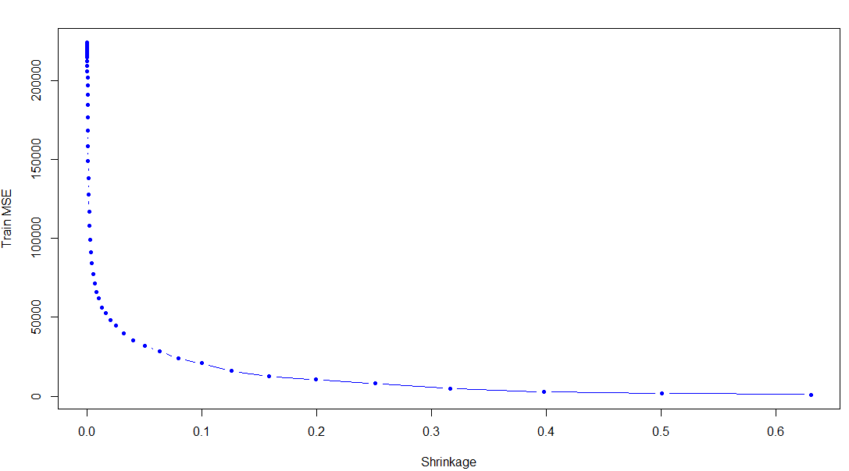

(d) Produce a plot with different shrinkage values on the x-axis and

the corresponding test set MSE on the y-axis.

Ans:

plot(lambdas, test.errors, type = "b", xlab = "Shrinkage", ylab = "Test MSE", col = "red", pch = 20)

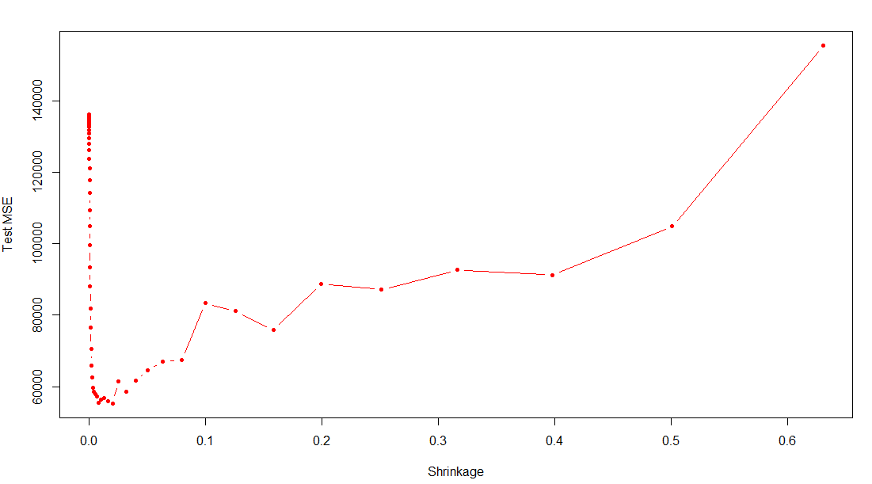

min(test.errors)

## [1] 0.2560507

lambdas[which.min(test.errors)]

## [1] 0.05011872

Here the Minimum test error is obtained at λ=0.05.

e) Compare the test MSE of boosting to the test MSE that results from applying two of the regression approaches seen in Chapters 3.

Ans:

lm.fit = lm(Salary ~ ., data = Hitters.train)  
lm.pred = predict(lm.fit, Hitters.test)  
mean((Hitters.test$Salary - lm.pred)^2)

## [1] 0.4917959

set.seed(134)

x = model.matrix(Salary ~ ., data = Hitters.train)

y = Hitters.train$Salary

x.test = model.matrix(Salary ~ ., data = Hitters.test)

lasso.fit = glmnet(x, y, alpha = 1)

lasso.pred = predict(lasso.fit, s = 0.01, newx = x.test)

mean((Hitters.test$Salary - lasso.pred)^2)

[1] 0.4701

Here both linear model and regularization like Lasso have higher test MSE value than boosting value.

(f) Which variables appear to be the most important predictors in

the boosted model?

Ans:

boost.best = gbm(Salary ~ ., data = Hitters.train, distribution = "gaussian", n.trees = 1000, shrinkage = lambdas[which.min(test.errors)])

summary(boost.best)

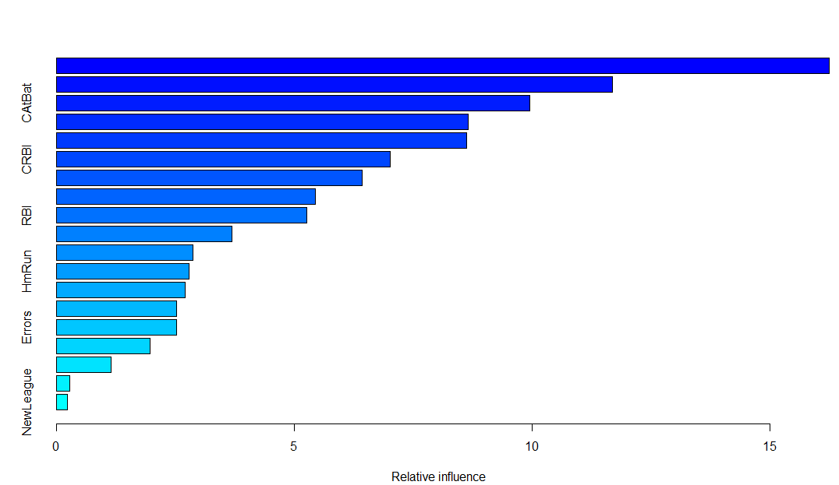

var rel.inf

CHmRun CHmRun 16.2464377

Walks Walks 11.6816442

CAtBat CAtBat 9.9537777

Years Years 8.6510975

Hits Hits 8.6259821

CRBI CRBI 7.0184910

PutOuts PutOuts 6.4172370

CWalks CWalks 5.4451756

RBI RBI 5.2644794

CHits CHits 3.6809891

AtBat AtBat 2.8699489

HmRun HmRun 2.7874174

CRuns CRuns 2.7066622

Assists Assists 2.5190996

Errors Errors 2.5151030

Division Division 1.9650221

Runs Runs 1.1423270

League League 0.2773784

NewLeague NewLeague 0.2317301

We notice that CAtBat, CRBI and CWalks are three most important variables in that order.